The Automated DA Form 3355 User’s Manual.

Dated 22 August 2005

Any changes to this manual can be accomplished by contacting Enlisted Promotions Branch at HRC-Alexandria

Table on Contents:

Title Page

Administrative information in accomplishing 3 the Automated DA Form 3355

I. The promotion process:

Promotion worksheet preparation 4-10

Subsequent actions to board appearance 10-12

II. Reevaluation 13-17

Summary of Requested Changes 18

This user manual is meant to be viewed as a draft and by no means considered inclusive. The Enlisted Promotions branch will update this manual on a regular basis to ensure that Human Resource specialists have the most up to date information to accomplish their promotion functions.

Websites of utmost importance:

TAPCMSPE@hoffman.army.mil

To request access to the Automated DA Form 3355

https://emilpo.ahrs.army.mil

eMILPO training website: This website should be used to become familiar with how to update pertinent information on eMILPO that affects a Soldier’s promotion record.

https://www.erec.army.mil/new_da3355/ako_login.htm

This is the initial login of the automated DA Form 3355

https://www.hrc.army.mil/site/active

The Enlisted Promotion Branch’s website. This website has a plethora of information to help the HR specialist in accomplish a myriad of promotion actions.

https://www.hrc.army.mil/site/active/select/TechCert.htm

Technical Certifications listing

IMPORTANT!!!!!

The promotion authority must identify by memorandum a primary and secondary representative of the human resources section (S1) that will be authorized access. The memorandum will contain the representative’s name, rank, SSN, phone number, email address and AKO ID. The memorandum should be forwarded via email to TAPCMSPE@HOFFMAN.ARMY.MIL. Memorandums previously received by this office remain in effect and are activated. Failure to comply will result in this response:

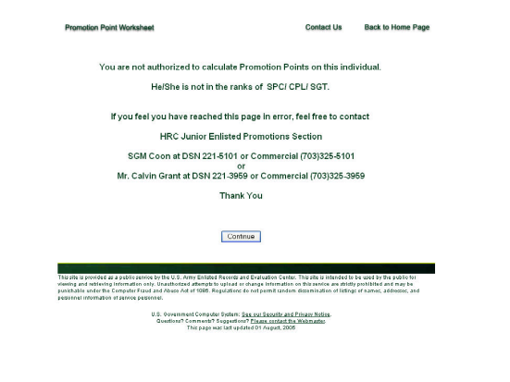

I. THE PROMOTION PROCESS:

- Unit HR specialist prepares Unit Enlisted Promotion Report, forwards to the unit commander to select Soldiers for board appearance to SGT/SSG NLT the third duty day of the month preceding the board month.
- Unit commander will personally review the report for accuracy and identify Soldiers to be recommended for promotion. Commander will annotate “YES” for those recommended or “NO” for those not recommended.
- Unit commander will return completed report to BNS1 no later than the fifth day of the month preceding the board month. Commander will also provide weapon qualification, IAW AR 600-8-19, paragraph 3-46a (Can only be updated through eMILPO), current APFT information, IAW AR 600-8-19, paragraph 3-46b (Can only be updated through eMILPO) and duty performance memorandum/evaluation (Can only be updated through the initial entries made on the Automated DA Form 3355 [FIGURE 1] or through the points menu [FIGURE 2]) for Soldier(s) recommend.
Found on eMILPO web-based training under: web-based training/course/test/APFT or web-based training/course/test/weapons qualification. Attention must be placed on the APFT and Weapon’s Qualification area as they may only be one and two years old respectively. When the automated DA Form 3355 pulls the APFT information from eMILPO, it automatically assigns the date of the first of the month as a result of eMILPO only containing four digit entries. Therefore, in those rare cases where a Soldier has a valid APFT just short of a year (Packet preparation on 10 Aug 2005, last APFT 28 Aug 2004), the system automatically gives a date of 1 Aug 2004 as the APFT date and awards zero points. In those instances that this occurs, the HR specialists will change the through date of the APFT (i.e. September 2005) through eMILPO and keep a memorandum for record so that the Soldier can be awarded the proper points. The same rules apply with weapon’s qualification. In addition, if a Soldier has been exempted from weapon’s qualification, the eMILPO entry must be the last weapon’s qualification with the date of the memorandum as the effective date. Therefore, a Soldier’s weapon’s entry will be checked at a minimum, every two years.

FIGURE 1 FIGURE 2

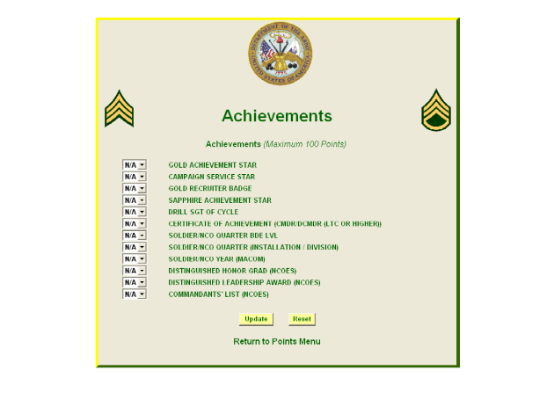

- The unit HR will schedule and conduct appointments for Soldiers recommended for board appearance NLT the 15th of the month. During the appointment, the HR specialist accesses the automated DA Form 3355. At the promotion point worksheet additions screen, input unit commander’s duty performance points (Section A, Part II (Can only be updated through the initial entries made on the Additions screen [FIGURE 3] or through the points menu [FIGURE 4]). This area will be a drop down menu, with 30 point maximum for each category.

FIGURE 3 FIGURE 4

- Section B, Part II of the additions screen (Can only be updated through the initial entries made on the Additions screen [FIGURE 5] or through the points menu [FIGURE 6]) allows the user to add achievements not normally listed on a Soldier’s ERB, this too will be a drop down menu to choose the number of achievements, not the achievements themselves.

FIGURE 3 FIGURE 4

- Unit HR specialist and Soldier will review the promotion point worksheet additions screen for accuracy with supporting documentation. Once review of the additions screen is complete, the HR specialist will click on “Initiate New DA 3355” for all initial DA Forms 3355 and “Edit” for all reevaluations and promotion point adjustments.
- The unit HR specialist will now begin reviewing the DA Form 3355 on the recommended Soldier (FIGURE 7).

FIGURE 7
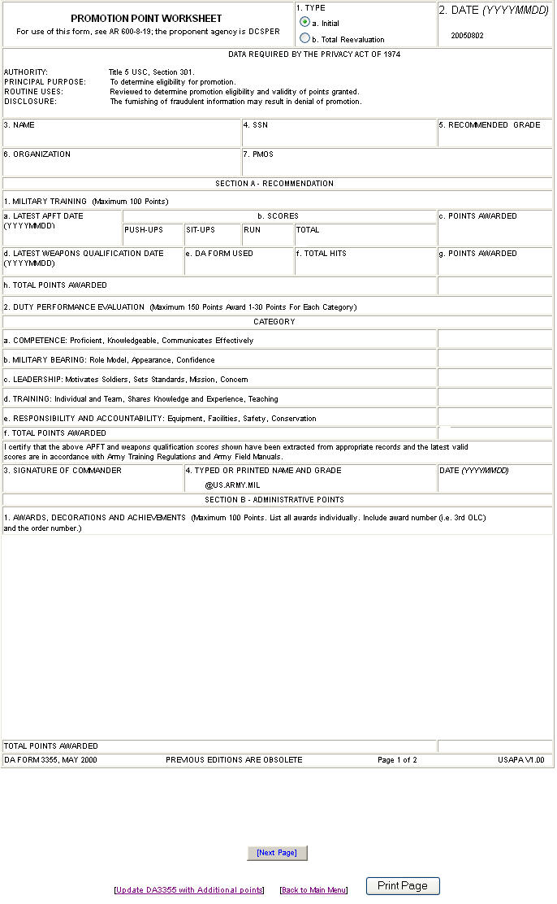

- The unit HR specialist reviews the first page of the DA Form 3355, verifying that all entries for duty performance and non-eMILPO awards are reflected on the form. The HR specialist ensures that Section B, 1. reflects current awards IAW AR 600-8-19, paragraph 3-47. If awards are missing on the promotion worksheet, that are normally found on the ERB, then the only to update these types of awards is through eMILPO. Found on eMILPO web-based training under: web-based training/course/individual awards.
- Once all data is reflected accurately, the HR specialist will either click on “Next Page” if it is an initial or will click on “Update DA3355 with Additional points” if it is a reevaluation or promotion point adjustment.
- Prior to the system allowing the user to view the second page of the DA Form 3355, it prompts the user to review and select courses that are currently listed in the database for military education (FIGURE 8). The HR specialist must select those courses that the Soldier is to be awarded promotion points for, and not those that are required my PMOS. NOTE: Same rules apply for military education, IAW AR 600-8-19, paragraph 3-48. User must specify the title of course and the number of hours. The HR specialist is also reminded that the only avenue to update military education is through eMILPO. If the HR specialist is not able to update the Soldier’s military education through eMILPO, they will utilize the “Certificate of Training” page (FIGURE 9), found under the “Points Menu” page (FIGURE 10). Additionally, the HR specialist will contact HRC, Enlisted Promotions, to request inclusion of the omitted military education course within future iterations of eMILPO. Found on eMILPO web-based training under: web-based training/course/education/military education.

FIGURE 8 FIGURE 9
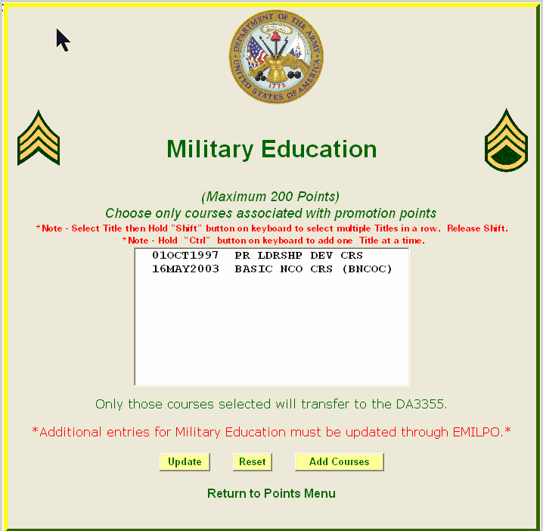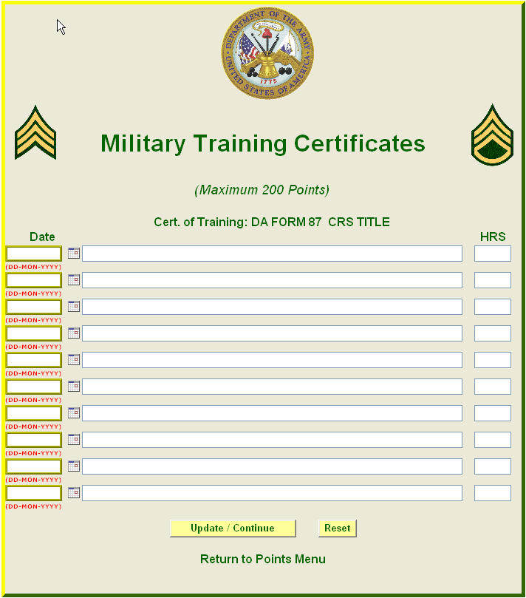

FIGURE 10

- Upon successful completion of military education courses by the HR specialist, the “Update/Continue” button will be pressed.
Prior to the system allowing the user to view the second page of the DA Form 3355, it now prompts the user to review those courses, listed under one transcript, that are currently listed in the database for civilian education (FIGURE 11). Additional information can be found at https://www.hrc.army.mil/site/active/select/CivEdProcedure.htm. A master list of accredited civilian education institutions will be available at a later date. Until such time, continue to use current avenues of confirmation of accreditation. To view how to update military or civilian education, the HR specialist can go to the eMILPO web-based training under: web-based training/course/education/civilian education.

- The first item under the civilian education screen is that of the institution where civilian education was accomplished and however many semester hours. NOTE: If the HR specialist is trying to input a transcript in eMILPO that is quarter hours, adjustments/calculations must be made to convert into semester hours. If a Soldier has a Master’s Degree, a manual change of semester hours must be accomplished to cap out the Soldier’s points of civilian education. The HR specialist must manually input any CLEP/DANTES test taken separate from any education transcript, IAW AR 600-8-19, paragraph 3-49a(4) (FIGURE 12). This screen also allows for credit of degree completion in current rank, IAW AR 600-8-19, paragraph 3-49a(3). Lastly, the HR specialist adds any technical certifications IAW AR 600-8-19, paragraph 3-49a(5) (FIGURE 13). An additional source for technical certifications is https://www.hrc.army.mil/site/active/select/TechCert.htm. This section requires the title of the certification with date group of DD/MMM/YYYY, i.e. 17/APR/2005. NOTE: Same rules apply for civilian education, IAW AR 600-8-19, paragraph 3-49.

FIGURE 11 FIGURE 12
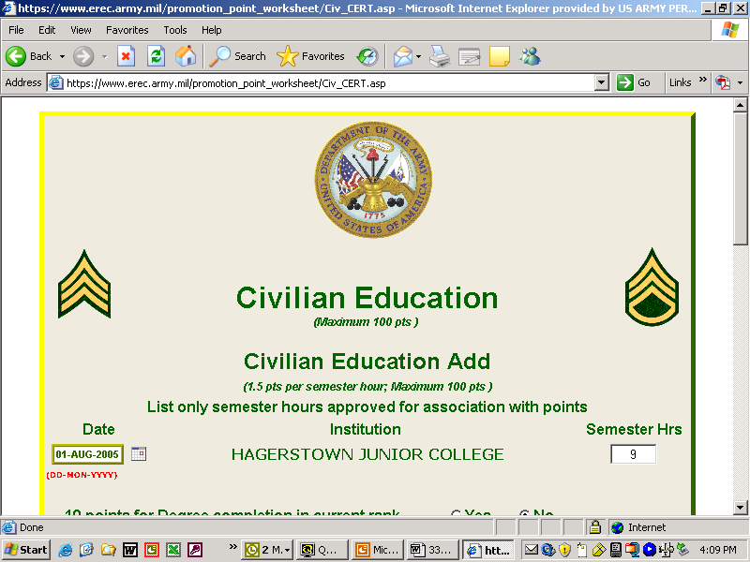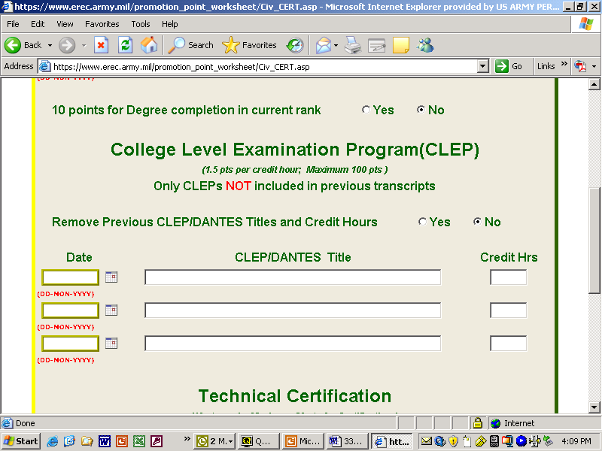

FIGURE 13
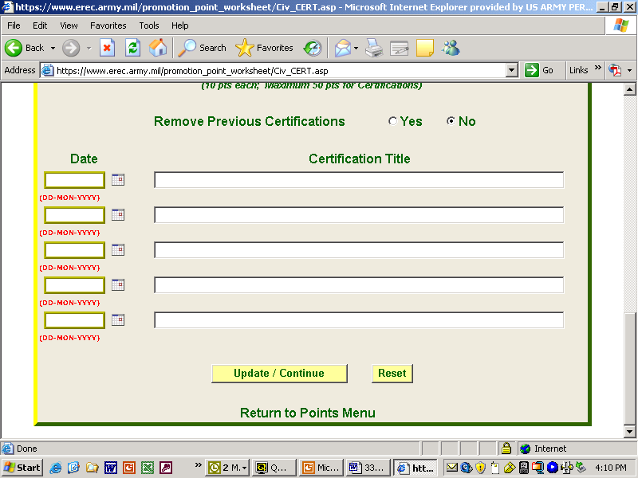

- Upon successful completion of military education courses by the HR specialist, the “Update/Continue” button will be pressed.
- The HR specialist can now view the second page of the DA Form 3355 (FIGURE 14).

FIGURE 14

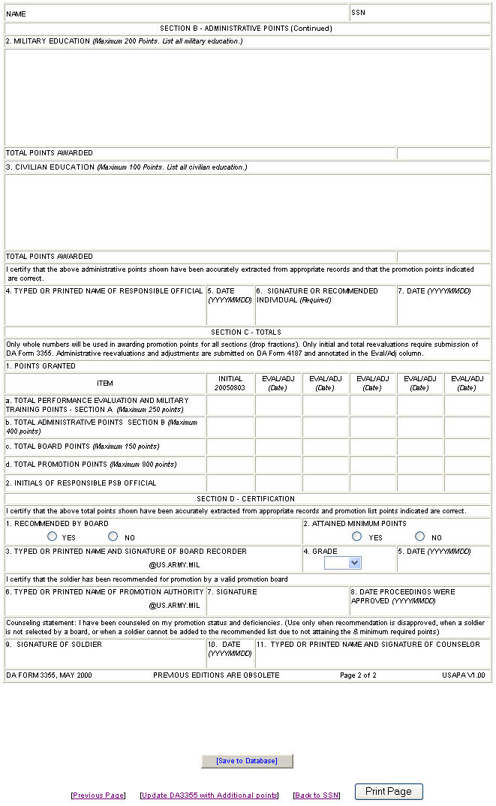

- The HR specialist will verify all of Section B and C, minus “Total Board Points” and “Total Promotion Points”. Block 4 will have a drop down menu for rank and will provide the end of the AKO address, just prior to the “2” needs to be inputted.
- If there is data that the HR specialist cannot update, the HR specialist will coordinate with the appropriate office capable of making said changes to update eMILPO no later than the 20th of the month prior to board appearance.
- The HR specialist prints a working copy of the DA Form 3355 and provides the Soldier and Board recorder a copy, after clicking the “Save to Database” button. Note: Since board points, responsible official’s initials, recommendation of board, and minimum points attained weren’t completed, the record will be saved as a draft and future updates will be conducted in the edit mode.
- No later than the first duty day after the promotion board is adjourned, the HR specialist inputs the Soldier’s board points in Section C, Item 1C of the promotion point worksheet, found within the points menu screen (FIGURES 15-16). Soldier and HR specialist verify all sections of the promotion point worksheet, and then the HR specialist saves to database, prints DA Form 3355 and obtains Soldier’s signature.

FIGURE 15 FIGURE 16
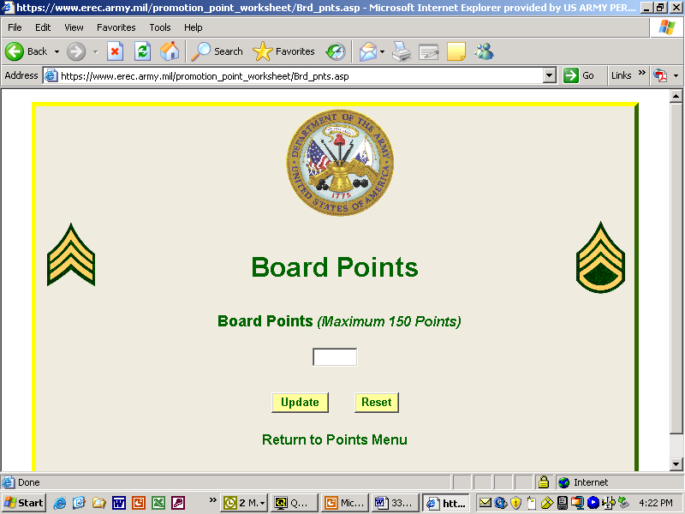
- The unit board recorder prepares board proceedings and forwards the board proceedings and DA Form 3355 to the unit’s senior HR specialist (currently the PSB or equivalent) for review and validation. The unit senior HR specialist will initial section C, item 2 as the responsible official only after verifying section C as described in AR 600-8-19, Chapter 3.
- Before a promotion packet is consider complete, section D must be updated and verified. Blocks 3 & 6 will require input and @US.ARMY.MIL will be supplied, block 4 will only have a drop down menu for rank. Blocks 9 through 11 will be accomplished simultaneously if used. After these blocks have been completed, “Save to Database” should be pressed, and the document will be saved as a completed record and the only future updates will be as a reevaluation.
- The unit HR specialist will forward the board proceedings and DA Forms 3355 to the board president and promotion authority for signature and approval. After approval of the board proceedings, copies of the approved board proceedings and DA Form 3355 will be forwarded to the servicing promotion work center NLT the 20th of the board month.
- The promotion work center will submit promotion point transactions subsequent to the receipt (FIGURE 17). Print updated screen and recommended list NLT the 25th of the board month. Verify recommended list for the newly recommended Soldiers and provide a copy to the BNS1, along with a copy of the update screen NLT the first duty day after the 25th of the board month.

FIGURE 17

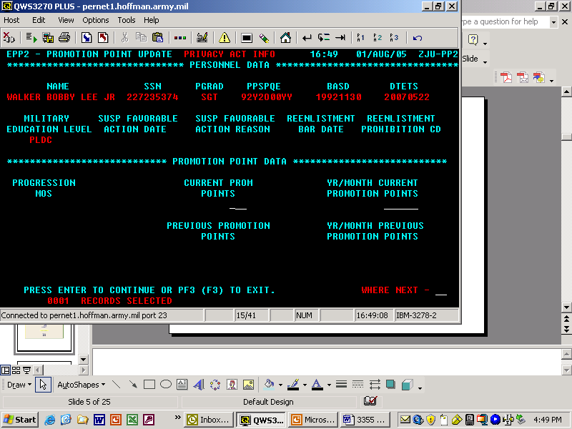

- The HR specialist will review the updated recommended list, resolve any discrepancies and have recommended Soldiers initial the list NLT the last duty day of the board month. Post recommended list (with blackened SSNs) on bulletin board.
- The Soldier will monitor and verify the recommended list and immediately notify the commander of any discrepancies using established local procedures.

II. Reevaluations will be accomplished IAW AR 600-8-19, chapter 3. The HR specialist will follow the steps for signing into the automated DA Form 3355, and will be prompted to submit a reevaluation (FIGURE 18).

FIGURE 18
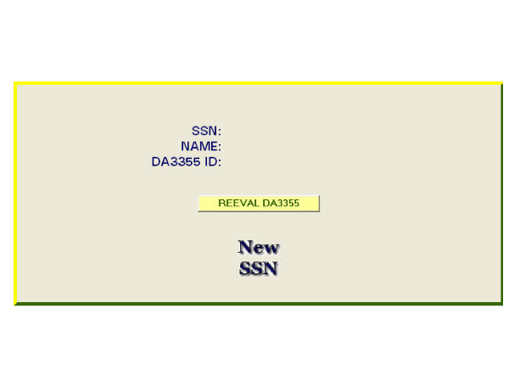
All reevaluation actions will be accomplished utilizing the Promotion Point Worksheet Points Menu, (FIGURE 19).

FIGURE 19
Below are depictions of the page for update when each title is activated.
FIGURE 20
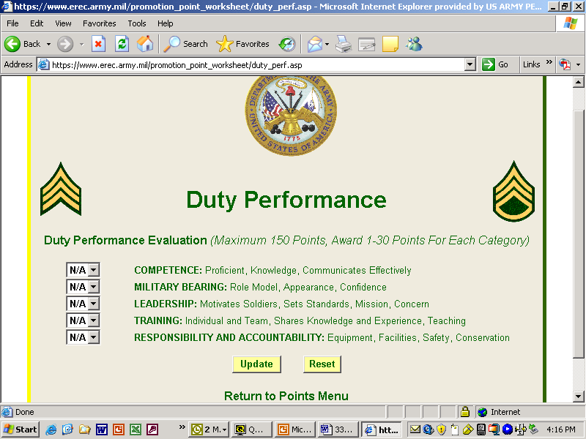

FIGURE 21
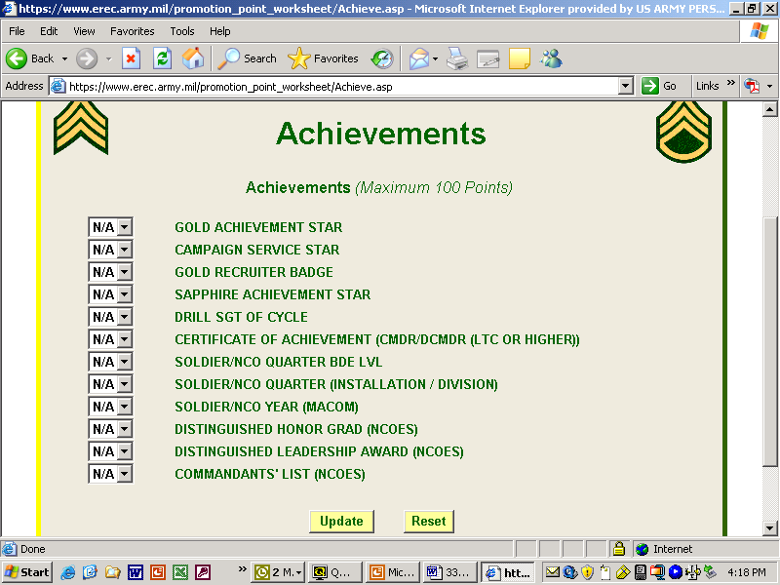

FIGURE 22
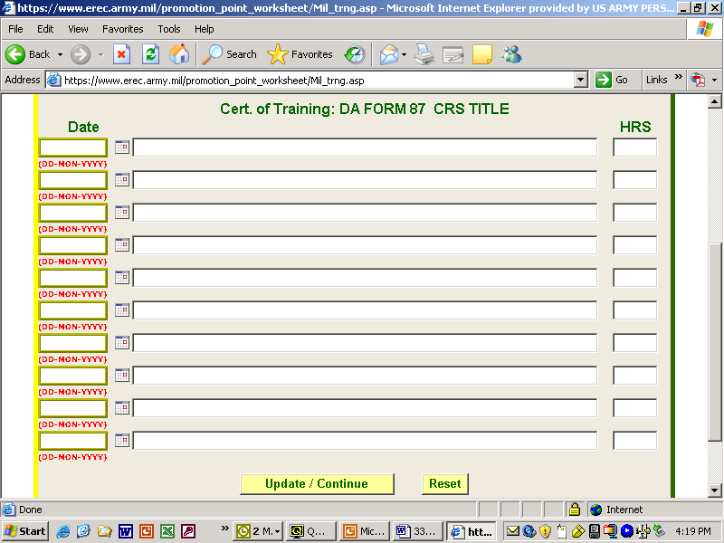
FIGURE 23
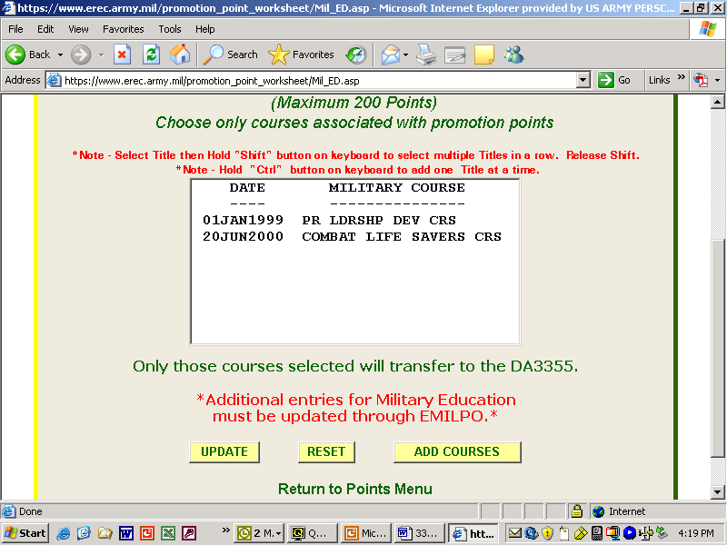

FIGURE 24
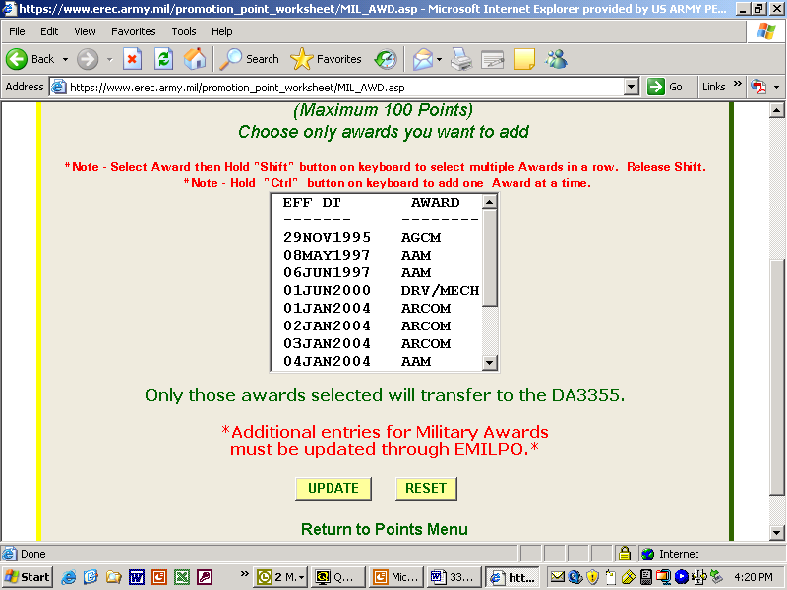
FIGURE 25
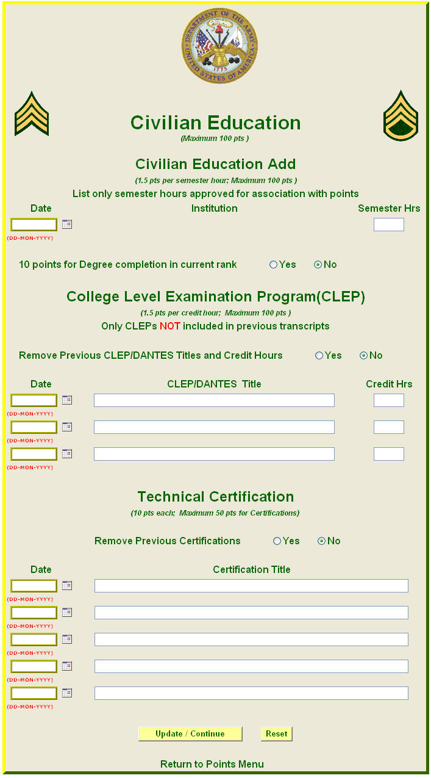

FIGURE 26
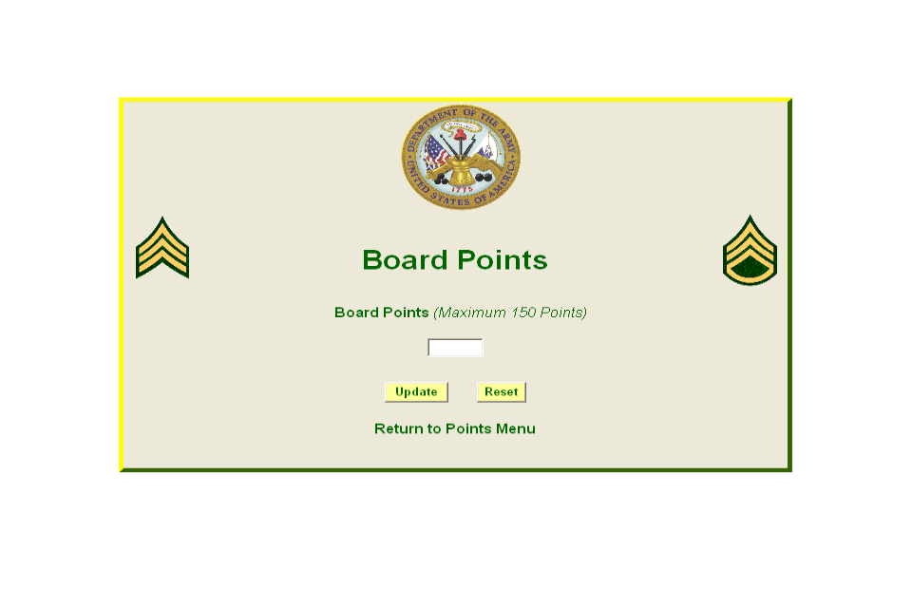

Summary of Requested Changes
(Any input or recommendations from the field is not only solicited but encouraged)

- Current system allows for 10 points for degree completion but no institution has to be listed. FIX: The system will be changed to only allow for credit of degree completion when an institution is listed.
- Current system deletes previous DA Form 87 entries when done at separate times. FIX: The HR specialist should input all DA Forms 87 at one time until the system is adjusted to allow for input at various stages.
- Current system does not show correspondence courses on preview window, only on DA Form 3355. FIX: The system will be changed to allow viewing of correspondence courses under the military education screen.
- Current system will error out with gibberish which cannot be translated to the average user. FIX: Ensure the system clarifies what the errors are when an erroneous entry is attempted.
- Current system will only consider 999 correspondence course hours. FIX: Allow for four digit entries.

